Communication and language
. I can continue a conversation for many turns.
I can use talk to organise myself and my play: “Let’s go on a bus... you sit there... I’ll be the driver.”
I know how to start a conversation with an adult or a friend.

Physical Development
I can independently carry out self-care routines such as getting dressed and undressed, putting on my own coat and doing up zips.
I can hold a pen comfortably and use it with good control.
I know how to hold a pen using a comfortable grip.

Personal, social and emotional Development
I can talk about my feelings using words like ‘happy’, ‘sad’, ‘angry’ or ‘worried’.
I can put on my own coat, wellies and shoes.
I can use a knife to cut my own snack.
I know how to express how I am feeling.
I know how to be independent with self-care skills such as feeding myself, dressing and undressing.
I know how to eat independently and how to use a knife and fork.

cv
cv
cv
cv
cv
cv
cv
cv
cv
cv
cv
cv
- cv
Literacy
Phonics
Progression of sounds: v w y z qu ch
I can identify initial sounds of words and objects
I know how to blend a wider range of words using oral blending.
I can match my name to my picture.
Phase 1 Phonological Awareness: Revise Aspects 6-7
Aspect 4 Rhythm and Rhyme
Aspect 5 Alliteration

Writing
I can use emergent writing in my play.
I can engage in extended conversations about stories, learning new vocabulary.
I know how to write some letters accurately.
I know how to talk about different parts of a story.

Preschool Summer Holidays
Mathematics
I can make comparisons between objects relating to weight and capacity. I can describe a sequence of events, using words such as ‘first’, ‘then...’
I know and understand words such as ‘heavy, light, full, empty, half full, half empty, nearly’ to describe weight and capacity.
I know how to link numerals to amounts: for example, showing the right number of objects to match the numeral, up to 5.

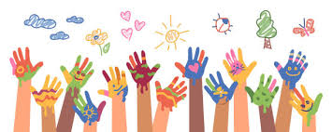

Expressive arts and design
I know how to draw with increasing complexity and detail, such as representing a face with a circle and including details. I can use drawing to represent ideas like movement or loud noises.
I know how to create my own songs.
I can improvise a song around one I already know

Understanding the world
I can talk about different countries in the world and the differences I have experienced or seen
I am developing positive attitudes about the differences between people. I know that there are different countries in the world
​

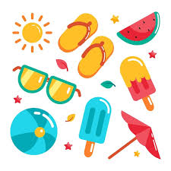
- cv
cv
cv

cv
English
Mathematics
Science
History
Geography

R.E
Art
D.T
Music
P.E
PSHE

Key:

Wow
Visit to the sea side/Whisby Nature Park

