Spires Federation
Policy


Sex and Relationships
Policy

Date : February 2024
Review Date: February 2026

The Spires Federation family of small schools is committed to excellence. We intend to equip our pupils with the skills they need to develop positive relationships, understand the importance of family and learn the responsibilities that are integral to relationships.
The aims of relationships and sex education (RSE) at our school are to:
• Provide a framework in which sensitive and honest discussions can take place.
• Prepare pupils for puberty, and give them an understanding of sexual development and the importance of health and hygiene.
• Help pupils develop feelings of self-respect, confidence and empathy.
• Create a positive culture around issues of sexuality and relationships.
• Teach pupils the correct vocabulary to describe themselves and their bodies.
• We will nurture and develop the strong relationships through collaboration between the schools and their wider communities.
• At Digby and Dunston, as Church of England schools, we believe that every pupil is unique in the sight of God. We aim to provide a Christian environment for every pupil, including opportunities to worship together and with our local communities.
Statutory Requirements
“The Relationships Education, Relationships and Sex Education and Health Education (England) Regulations 2019, made under sections 34 and 35 of the Children and Social Work Act 2017, make Relationships Education compulsory for all pupils receiving primary education…They also make Health Education compulsory in all schools except independent schools. Personal, Social, Health and Economic Education (PSHE) continues to be compulsory in independent schools.”
DfE Guidance 2019 p.8
“Today’s children and young people are growing up in an increasingly complex world and living their lives seamlessly on and offline. This presents many positive and exciting opportunities, but also challenges and risks. In this environment, children and young people need to know how to be safe and healthy, and how to manage their academic, personal and social lives in a positive way.” “This is why we have made Relationships Education compulsory in all primary schools in England…as well as making Health Education compulsory in all state-funded schools.”
Secretary of State Foreword DfE Guidance 2019 p.4-5
As maintained primary schools we must provide relationships education to all pupils as per section 34 of the Children and Social work act 2017.
However, we are not required to provide sex education but we do need to teach the elements of sex education contained in the science curriculum.
In teaching RSE, we must have regard to guidance issued by the secretary of state as outlined in section 403 of the Education Act 1996.
At The Spires Federation we teach RSE as set out in this policy.

Definition
SRE is lifelong learning about physical, moral and emotional development. It is about the understanding of the importance of family life, stable and loving relationships, respect, love and care. It is also about the teaching of sex, sexuality, healthy lifestyles, diversity and personal identity. RSE involves a combination of sharing information, and exploring issues and values. It is not about the promotion of sexual activity.
Curriculum
At the Spires Federation, we teach Personal, Social, Health Education as a whole-school approach to underpin children’s development as people and because we believe that this also supports their learning capacity.
We follow the Jigsaw Programme which offers us a comprehensive, carefully thought-through Scheme of Work which brings consistency and progression to our children’s learning in this vital curriculum area. T
his also supports the “Personal Development” and “Behaviour and Attitude” aspects required under the Ofsted Inspection Framework, as well as significantly contributing to the school’s Safeguarding and Equality Duties, the Government’s British Values agenda and the SMSC (Spiritual, Moral, Social, Cultural) development opportunities provided for our children.
Our curriculum is set out as per Appendix 1 but we may need to adapt it as and when necessary.
The curriculum has been developed carefully, taking into account the age, needs and feelings of pupils. If pupils ask questions outside the scope of this policy, teachers will respond in an appropriate manner so they are fully informed and don’t seek answers online.
Primary sex education will focus on:
• Preparing boys and girls for the changes that adolescence brings
• How a baby is conceived and born Sex and Relationships Education Policy February 2022 (Revision Date: February 2024)
For more information about our curriculum, see our curriculum map in Appendix 1.
Delivery of RSE
RSE is taught within our personal, social, health and economic (PSHE) education curriculum. Biological aspects of RSE are also taught within the science curriculum, and other aspects are included in religious education (RE).
To ensure progression and a spiral curriculum, we use Jigsaw, the mindful approach to PSHE, as our chosen teaching and learning programme and tailor it to your children’s needs. The mapping document: Jigsaw 3-11 and statutory Relationships and Health Education, shows exactly how Jigsaw and therefore our school, meets the statutory Relationships and Health Education requirements.
This programme’s complimentary update policy ensures we are always using the most up to date teaching materials and that our teachers are well-supported.
Our RSE part of our PSHE curriculum will be taught in terms 5 and 6 under the titles: Relationships and Changing Me. This will be a part of the curriculum from EYFS through to Year 6, the topics will be re-visited each year to allow children to build their knowledge as they progress through school. Each is carefully adapted to meet the needs of the age group.
Relationships education focuses on teaching the fundamental building blocks and characteristics of positive relationships including:

• Families and people who care for me
• Caring friendships
• Respectful relationships
• Online relationships
• Mental well-being • Healthy eating
• Health and prevention
• Drugs, alcohol and tobacco
• Basic first aid • Being safe • Different types of relationship (including LGBT)
• Changing adolescent body
Early Years Foundation Stage:
As outlined in The Early Years Statutory Framework, ‘Personal, Social and Emotional Development’ is a prime area of learning. Through the EYFS curriculum, children are taught to play co-operatively, take turns with others, and to show sensitivity to others’ needs and feelings. Children are enabled to form positive relationships with adults and other children, and talk about how they, and others, show their feelings.
Sex and Relationships Education Policy February 2022 (Revision Date: February 2024) Through the ‘Understanding the World’ Early Learning Goal, children learn that others do not always enjoy the same things as they do. They are taught about similarities and differences between themselves and others, and among families, communities and traditions. They talk about their own, and others’ behaviour and learn that some behaviour is unacceptable. They develop their understanding of ways to keep healthy and safe. Children make observations of animals and plants, explain why some things occur, and talk about changes.
For further information on what is covered and when, please refer to appendices 1 and 2.
Our PSHE is also aligned with the Church of England’s, “A charter for faith sensitive and inclusive relationships education, relationships and sex education (RSE) and health education (RSHE)” and draws on the advice given in the Church of England document ‘Valuing All God’s Children: Guidance for Church of England schools on challenging homophobic, biphobic and transphobic bullying’ (Church of England Education Office, second edition updated summer 2019).
These areas of learning are taught within the context of family life taking care to ensure that there is no stigmatisation of children based on their home circumstances (families can include single parent families, LGBT parents, families headed by grandparents, adoptive parents, foster parents/carers amongst other structures) along with reflecting sensitively that some children may have a different structure of support around them (for example: looked after children or young carers).

Our PSHE Curriculum Coverage
Whole-school approach
Our scheme, covers all areas of PSHE for the primary phase including statutory Relationships and Health Education. The table below gives the learning theme of each of the six Puzzles (units) and these are taught across the school; the learning deepens and broadens every year.
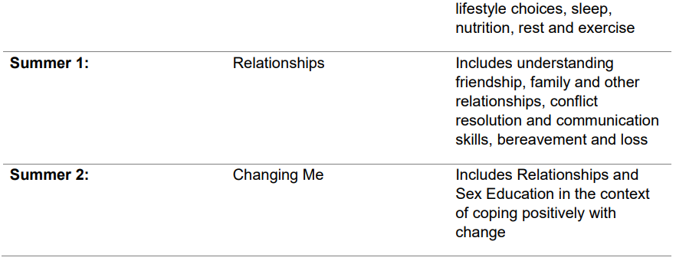
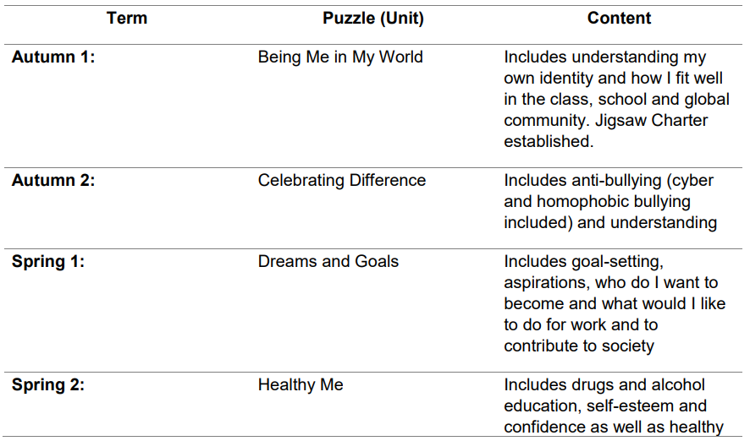
At The Spires Federation, we allocate lesson time to PSHE each week in order to teach the PSHE knowledge and skills in a developmental and age-appropriate way.
These explicit lessons are reinforced and enhanced in many ways: Assemblies and collective worship, praise and reward system, through relationships child to child, adult to child and adult to adult across the school. We aim to ‘live’ what is learnt and apply it to everyday situations in the school community.
Class teachers deliver the weekly lessons to their own classes.
Roles and Responsibilities
The Governing Board
The governing board will approve the RSE policy, and hold Mr Walls to account for its implementation.
The Headteacher and Designated Safeguarding Lead
Miss Winters is responsible for ensuring that RSE is taught consistently across the school, and for managing requests to withdraw pupils from non-statutory components of RSE.
Staff
Staff are responsible for:
• Delivering RSE in a sensitive way
• Modelling positive attitudes towards RSE
• Monitoring progress
• Responding to the needs of individual pupils • Responding appropriately to pupils whose parents wish them to be withdrawn from the non-statutory components of RSE
Pupils
Pupils are expected to engage fully in RSE and, when discussing issues related to RSE, treat others with respect and sensitivity.
Parents’ Right to Withdraw
“Parents have the right to request that their child be withdrawn from some or all of sex education delivered as part of statutory Relationships and Sex Education”
(DfE Guidance p.17)
At the Spires Federation, puberty is taught as a statutory requirement of Health Education and covered by our Jigsaw PSHE Programme in the ‘Changing Me’ unit in Term 6.
Parents have a right to withdraw from the sex education element of this unit. As part of the Changing Me unit, we conclude that sex education refers to Human Reproduction, and therefore inform parents of their right to request their child be withdrawn from the PSHE lessons that explicitly teach this within this unit. This is the following lessons:
Year 4, Lesson 2 (Having a baby)
Year 5, Lesson 4 (Conception)
Year 6, Lesson 4 (Conception, birth)
The school will inform parents of this right through a letter sent out prior to the teaching of this unit in Term 6.

Equality, Inclusion and Support
Relationships and RSHE should be delivered in line with the Equalities Act and Public Sector Equality Duty to ensure those with protected characteristics do not face discrimination. Positive action is taken to deal with disadvantages affecting a group because of a protected characteristics.
In complying with the requirements of the Equality Act 2010, we value diversity, encourage respect for all and promote tolerance for, and celebration of, difference. We do not discriminate against pupils because of any protected characteristic (age, sex, race, disability, religion or belief, gender reassignment, pregnancy or maternity, marriage or civil partnership, or sexual orientation). At times, when there is an identified need, we may take positive action through our planning and delivery of RSHE to deal with disadvantages facing those with a particular characteristic.
RSHE will be accessible to all regardless of their gender or background. Through the delivery of RSHE, teachers will explore gender stereotypes and how they may limit a person’s potential and ensure that people of all genders receive information that is relevant to their needs.
There are many different faith and cultural perspectives on aspects of RSHE. We aim to deliver RSHE in a factual, non-judgmental way, ensuring that teachers do not promote one faith or cultural viewpoint, but rather provide a balanced approach that acknowledges the wealth of views and opinions of our community and teaches tolerance.
Parents and carers are key partners in RSHE and are best placed to support their children to understand how their learning at the Academy fits with their family’s faith, beliefs and values. To support this process we will ensure that parents are made aware of what will be taught and when.
We will use a range of materials and resources that reflect the diversity of the Academy population and encourage acceptance and tolerance. We want every child and family to feel included, respected and valued.
A range of different families and relationships will be explored within RSHE. All children whatever their identity, developing identity, or family background need to feel that RSHE is relevant to them and sensitive to their needs. Resources used will demonstrate awareness of both the Academy community and wider society where possible.
SEND
Teachers will plan in different ways and use a variety of teaching strategies to meet the needs of individuals. For some children, particularly those with special educational needs and disabilities, a tailored approach may be necessary to ensure learning outcomes are met – this will be discussed with parents/carers and based upon the individual needs of the pupil, prior to the session.
Vulnerable Pupils
Some pupils may have experienced adverse childhood experiences that may impact on their ability to engage with RSHE in a variety of ways. Care will be taken to ensure that, where this is the case, parents/carers are consulted about the most appropriate way for the pupil to access the curriculum.
Training
Staff are trained on the delivery of RSE as part of our continuing professional development calendar. The headteacher will also invite visitors from outside the school, such as school nurses or sexual health professionals, to provide support and training to staff teaching RSE. In addition to this, professionals will be invited in to deliver workshops to pupils including puberty and LGBT.
Monitoring Arrangements
The delivery of RSE is monitored by Mrs Miller (subject leader) through:
Planning scrutinies, learning walks and book scrutinies
Pupils’ development in RSE is monitored by class teachers as part of our internal assessment systems.
This policy will be reviewed by Governors every two years. At every review, the policy will be approved by the governing board and Miss Winters.
Appendix 1:
Curriculum map Relationships and sex education curriculum map
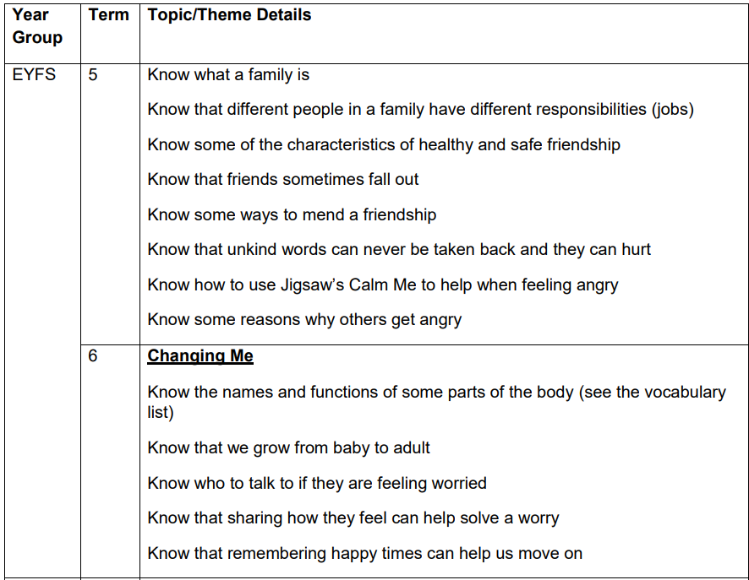
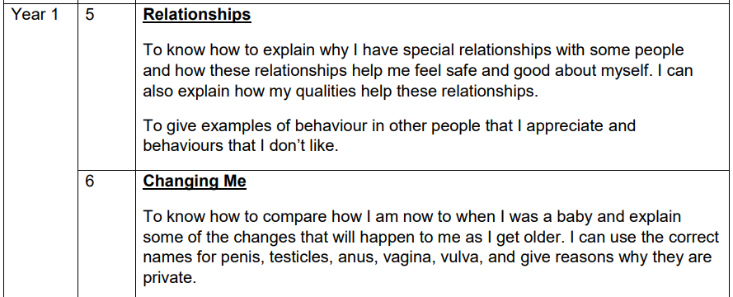

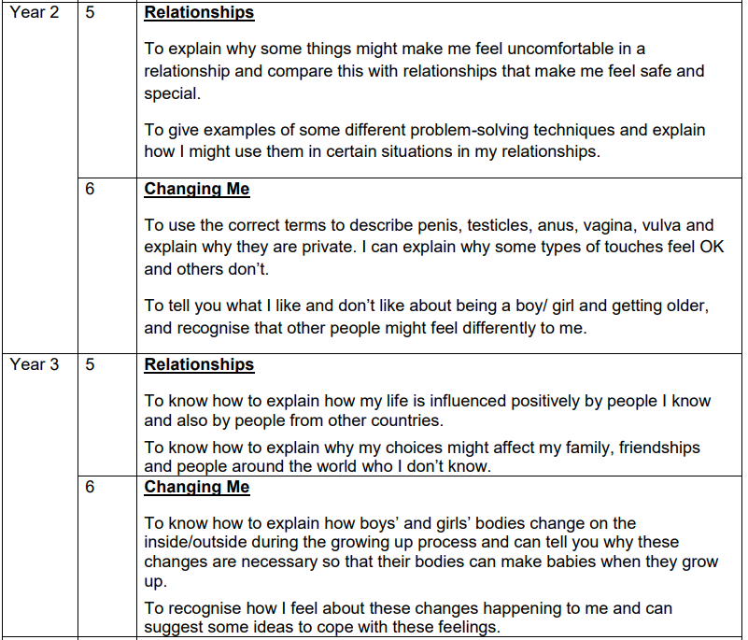

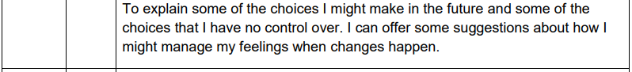
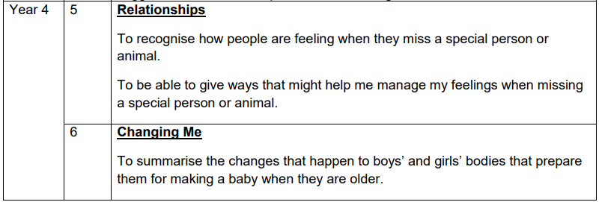

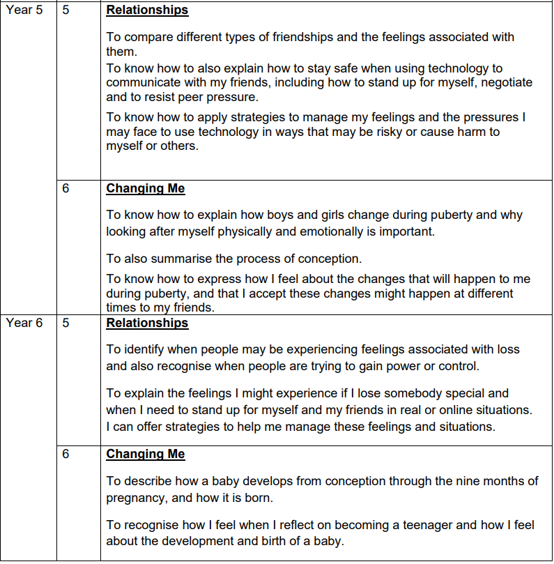

Appendix 2
Relationships Education in Primary schools – DfE Guidance 2019
The focus in primary school should be on teaching the fundamental building blocks and characteristics of positive relationships, with particular reference to friendships, family relationships, and relationships with other children and with adults. The guidance states that, by the end of primary school:
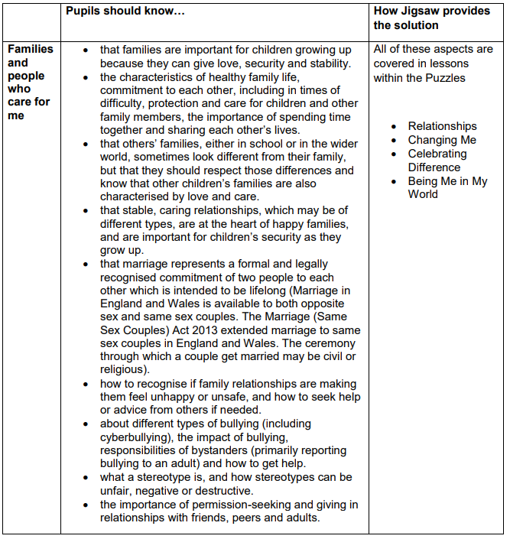
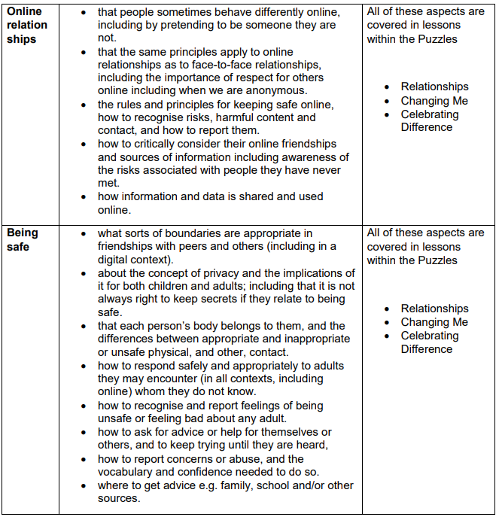

Physical health and mental well-being education in Primary schools – DfE Guidance
The focus in primary school should be on teaching the characteristics of good physical health and mental wellbeing. Teachers should be clear that mental well-being is a normal part of daily life, in the same way as physical health.
By the end of primary school:



