French LTP
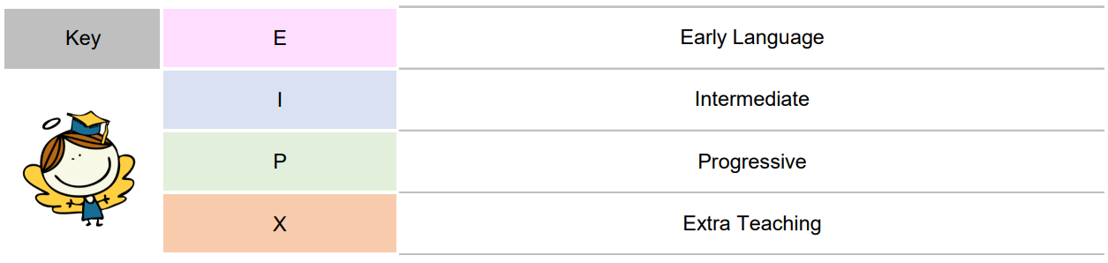
 | CYCLE 1 (A and C)
 | Adaptations: retrieval practice, explicit teaching of new vocab, key vocab mat, drawing, modelling, dual coding, mindmaps.
 | Year ¾ | Year 5/6
Autumn 1 | I’m Learning French (E)  Key learning for week:  - Pinpoint France and other French speaking countries on a map of the world.  - ask and answer the question ‘How are you?’ in French.  - say ‘Hello’ and ‘Goodbye’ in French.  - ask and answer the question ‘What is your name?’ in French.  - count to 10 in French.  - say 10 colours in French  Substantive knowledge  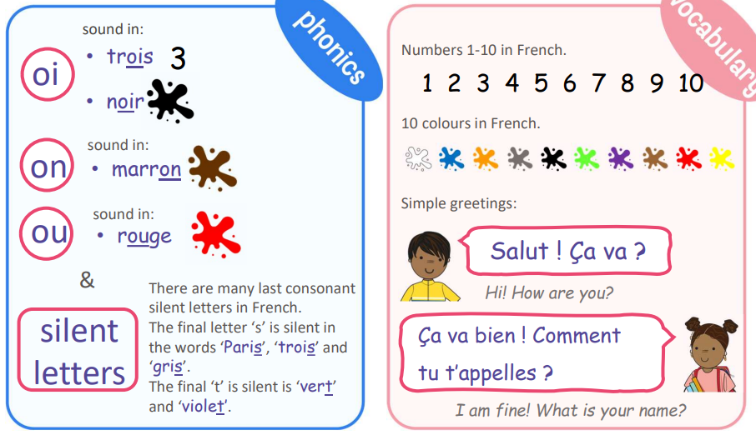  Disciplinary knowledge  I will learn more about the Francophone world.  I will learn how to use key greetings in French.  I will learn how to ask and answer the question ‘How are you?’ in French.  I will learn how to ask and answer the question ‘What is your name?’ in French. | Clothes (I)  Key learning for week:  - Repeat and recognise the vocabulary for a variety of clothes in French.  - Use the appropriate genders and articles for these clothes.  - Use the verb porter in French with increasing confidence.  - Say what they wear in different weather/situations.  - Describe clothes in terms of their colour and apply adjectival agreement.  - Use the possessives with increased accuracy  Substantive knowledge  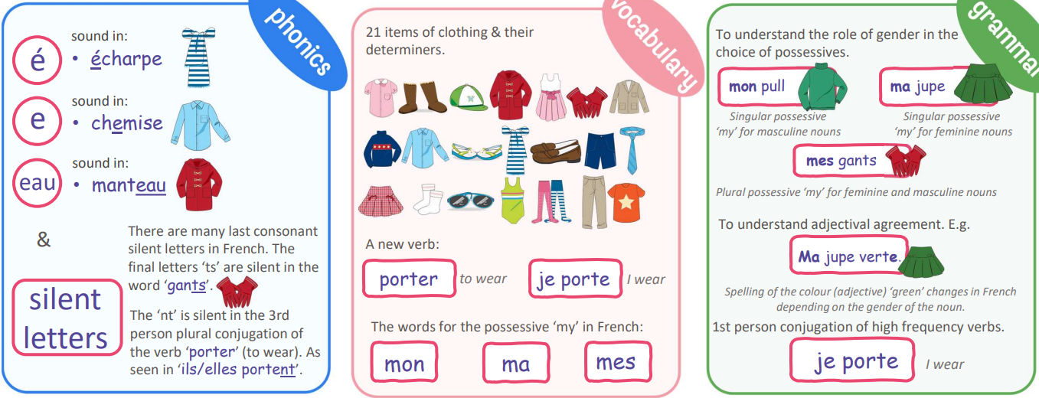  Disciplinary knowledge  I will learn 10 nouns for items of clothing and their determiners.  I will learn 11 more nouns for items of clothing and their determiners.  I will learn how to say what I am wearing in French using the verb ‘je porte…’ (I wear) plus the item of clothing.  I will learn more about adjectival agreement in French, describing items of clothing by colour and learning how to say ‘my’ in French.  I will use all my new knowledge in French to describe what I am packing in my suitcase for a holiday
Autumn 2 | Animals (E)  Key learning for week:  - Recognise, recall, and spell up to 10 animals in French with their correct determiners/ indefinite articles.  - Understand that there are more determiners/ articles in French than in English.  - Use and become more familiar with the high-frequency 1st person conjugated verb ‘je suis’ (I am), from the infinitive verb ‘être’ (to be).  Substantive knowledge  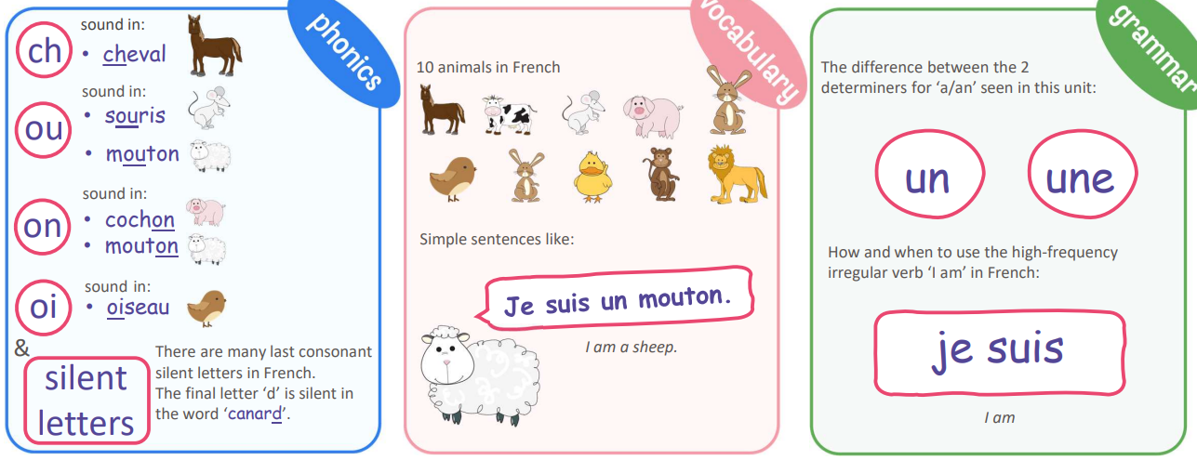  Disciplinary knowledge  I will learn 5 animal nouns in French with their correct determiner.  I will learn 5 more animal nouns in French with their correct determiner.  I will revise all 10 animal nouns with their determiner in French and start to attempt the spellings.  I will explore and understand better the role of the indefinite article/determiner in French.  I will learn how to use the first person conjugated verb ‘je suis’ (I am) in French | Traditions and celebrations  Key learning for week:  - Use key French question words related to famous traditions and famous celebrations in French-speaking countries.  - Respond to questions in French related to famous traditions and celebrations in French-speaking countries.  - Express an opinion on a tradition or celebration in French using the structure ‘C’est une fête…’ + adjective (It is a … festival) and attempt to apply accurately the rules of adjectival agreement in the description.  - Develop an appreciation of traditions and celebrations different to their own culture.  Substantive knowledge  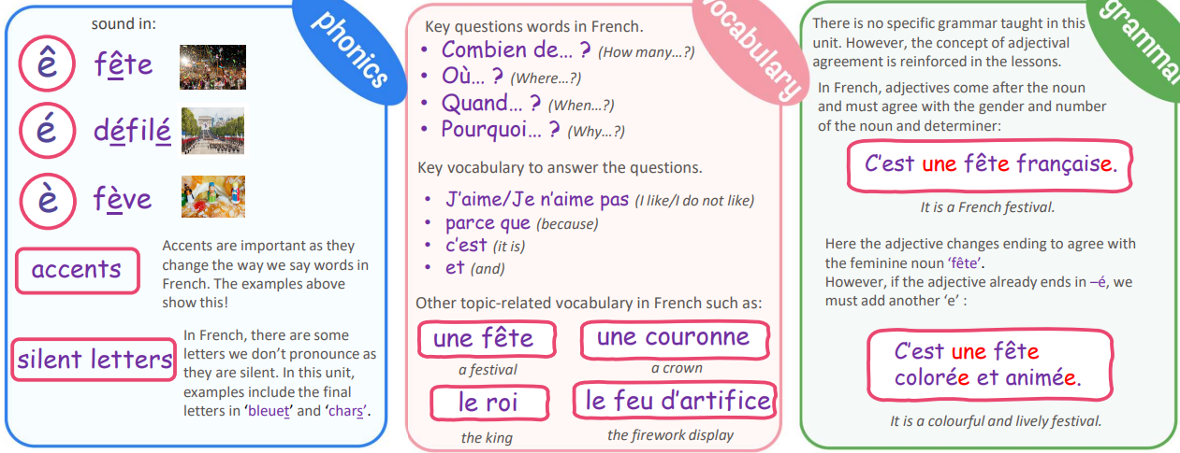  Disciplinary Knowledge  I will learn about the famous French festival, Le Carnaval de Nice, ask questions, give answers and express my opinion.  I will learn about the famous French celebration, La Fête des Rois, ask questions, give answers and express my opinion.  I will learn about the famous French tradition, Le Poisson d’avril, ask questions, give answers and express my opinion.  I will learn about the famous French celebration, La fête nationale française, ask questions, give answers and express my opinion about it.  I will learn about the famous French tradition, Le jour de l’Armistice, ask questions, give answers and express my opinion about it.
Spring 1 | Fruits (E)  Key learning for week:  - Name and recognise up to 10 fruits in French.  - Attempt to spell some of these nouns.  - Ask somebody in French if they like a particular fruit.  - Say what fruits they like and dislike.  Substantive knowledge  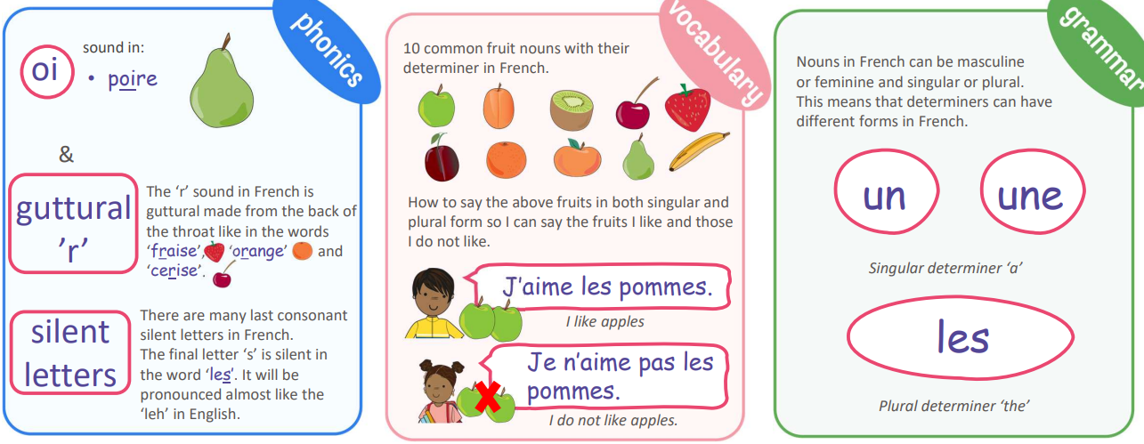  Disciplinary knowledge  I will learn and become more familiar with 5 fruit nouns with their determiners in French.  I will learn and become more familiar with 5 more fruit nouns with their determiners in French.  I will learn how to move singular nouns to plural form in French.  I will learn how to use the structure ‘j’aime’ (I like) with the fruit nouns.  I will learn how to use the negative structure ‘je n’aime pas’ (I do not like) with the fruit nouns | At the tearoom (I)  Key learning for week:  - Remember and recall a wide variety of foods, snacks, and drinks (with their indefinite article/determiner) typically served in a salon de thé.  - To understand better how to change a singular noun to plural form.  - Perform a short role-play ordering what they would like to eat and drink.  Substantive knowledge  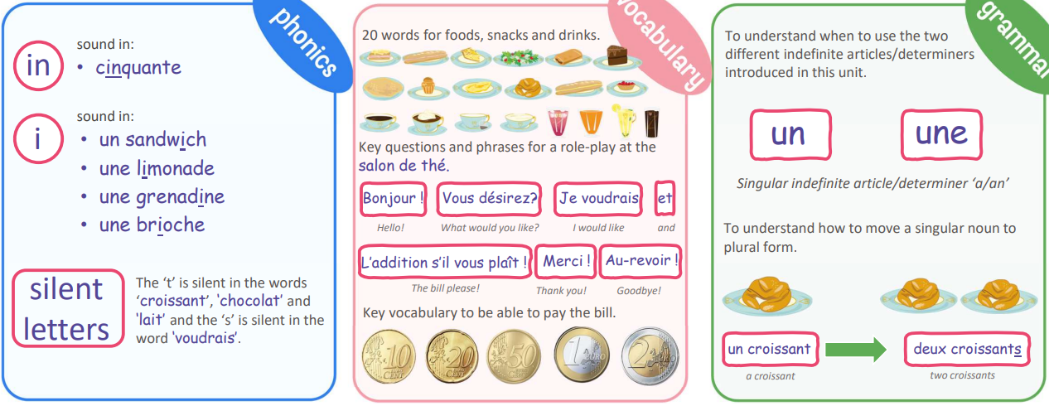  Disciplinary knowledge  I will learn 11 different foods, snacks and drinks in French with the correct indefinite article/determiner.  I will learn another 9 different foods, snacks and drinks in French with the correct indefinite article/determiner.  I will learn some key phrases to help me perform a role-play in the French salon de thé.  I will learn some more key phrases to help me perform a role-play in the French salon de thé.  I will learn about French currency and will use my knowledge of numbers to help calculate the bill in French
Spring 2 | I am able (E)  Key learning for week:  - Recognise, recall and spell 10 action verbs in French.  - Use these verbs in the infinitive to form positive and negative sentence structures with ‘je peux’ (I am able) and ‘je ne peux pas’ (I am not able).  - Attempt to combine positive and negative sentence structures to form longer and more complex sentences using the conjunctions ‘et’ (and / ‘mais’ (but).  Substantive knowledge  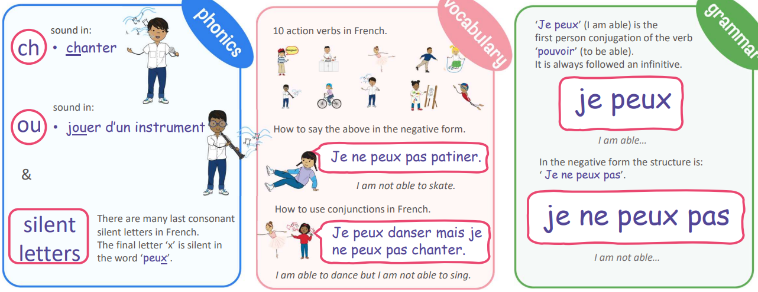  Disciplinary knowledge  I will learn 5 high frequency infinitive verbs in French.  I will learn 5 more high frequency infinitive verbs in French.  I will learn how to use the structure ‘je peux’ with the infinitive verbs in French.  I will learn how to use the negative structure ‘je ne peux pas’ followed by infinitive verbs in French.  I will learn how to use conjunctions ‘et’ (and) & ‘mais’ (but) in French | Olympics (I)  Key learning for week:  - Tell somebody in French the key facts of the history of the Olympics.  - Tell somebody in French the key facts of the modern Olympic games.  - Look for cognates and highlight key words when learning how to decode longer text in gist listening and reading in French.  - Say the nouns in French for key sports in the current Olympic games.  - Conjugate the irregular verb FAIRE enabling the students to say what sports they play and what sports they do not play.  - Understand the concept of de la, de l’ and du when you say you play a sport in French.  Substantive knowledge  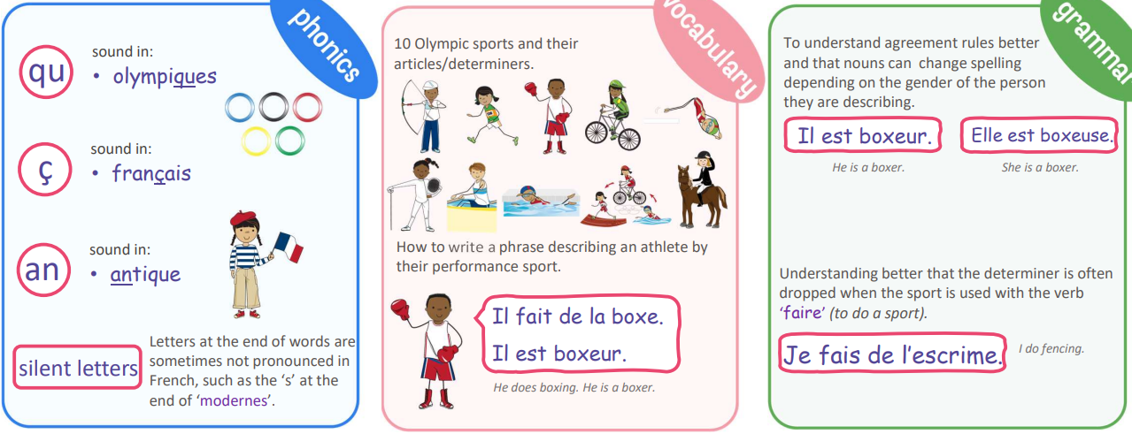  Disciplinary knowledge  I will learn to listen attentively to longer passages in French, decoding using cognates.  I will learn to understand more of what I hear and read using story ordering to help me decode unknown language.  I will learn 10 nouns for Olympic sports with their correct articles/determiners.  I will learn how to say, ‘I do’ and ‘I do not do’ a particular sport using the verb ‘faire’ (to do) in French.  I will learn that nouns can change spelling in French depending on the gender of the person being described
Summer 1 | Presenting Myself (I)  Key learning for week:  - Count to 20.  - Say their name and age.  - Say hello and goodbye, then ask how somebody is feeling and answer how they are feeling.  - Tell you where they live.  - Tell you their nationality and understand basic gender agreement rules.  Substantive knowledge  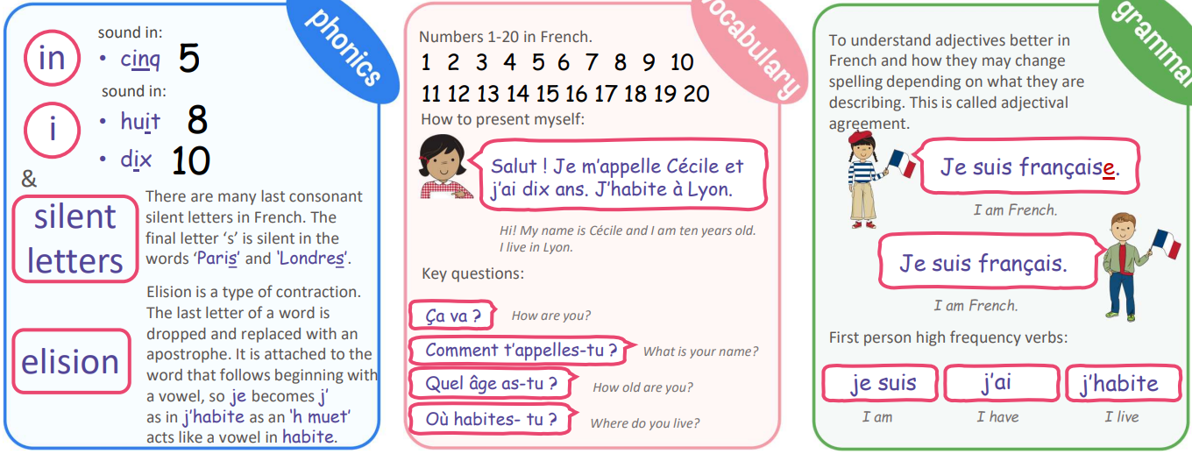  Disciplinary knowledge  I will use basic greetings in French, ask somebody how they are feeling and reply when asked to me.  I will ask somebody their name in French and reply when asked to me.  I will recall numbers 1-10 and count from 11-20 in French.  I will learn how to ask somebody how old they are in French and reply when asked to me.  I will learn how to ask somebody where they live in French and reply when asked to me.  I will learn how to express my nationality in French and understand basic gender agreement rules. | The weekend (P)  Key learning for week:  - Ask what the time is in French.  - Tell the time accurately in French.  - Learn how to say what they do at the weekend in French.  - Learn to integrate connectives into their work.  - Present an account of what they do and at what time at the weekend.  Substantive knowledge  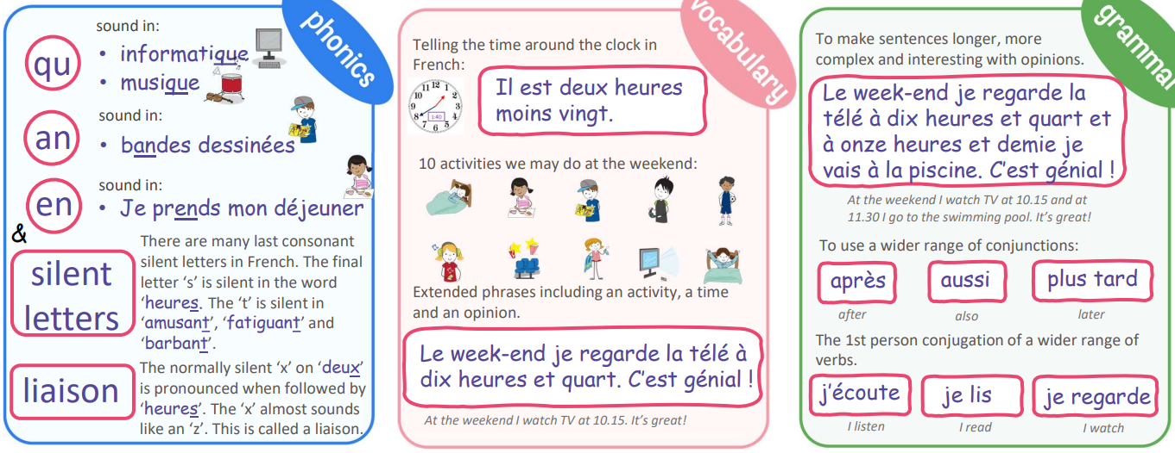  Disciplinary knowledge  I will learn how to tell the time around the clock in French.  I will learn 10 activities in French that I may do at the weekend.  I will consolidate my learning and focus on the spellings in French for the 10 activities.  I will integrate ‘at…’ plus a time into my spoken and written work about weekend activities.  I will use all my new knowledge from the unit to present to the class in spoken and/or written form.
Summer 2 | Habitats (I)  Key learning for week:  - Tell somebody in French the key elements that animals and plants need to survive in their habitat.  - Tell somebody in French examples of the most common habitats for plants and animals and give a named example of these habitats.  - Tell somebody in French which animals live in these different habitats.  - Tell somebody in French which plants live in these different habitats.  Substantive knowledge  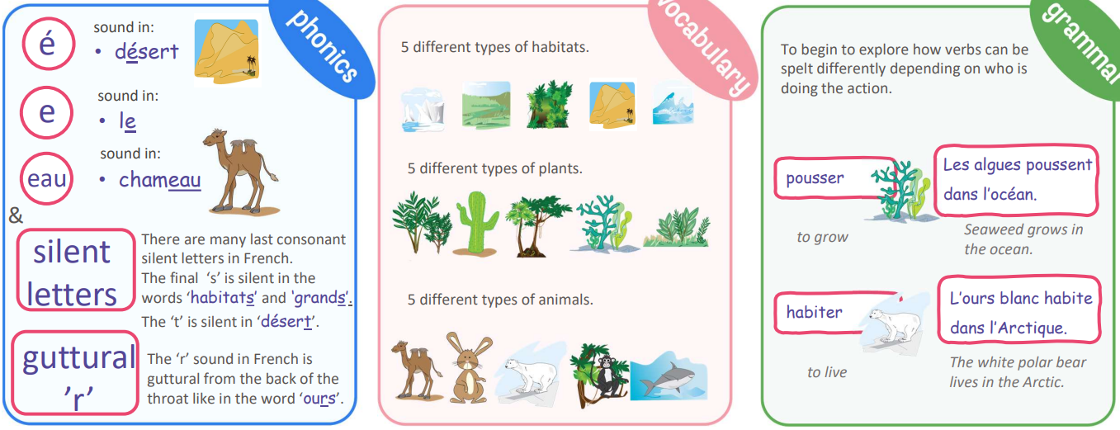  Disciplinary knowledge  I will learn the essential things plants and animals need to survive in French.  I will learn about 5 key habitats around the world in French. Objective.  I will learn to use the verb ‘pousser’ (to grow) to express which plants grow in these habitats.  I will learn to use the verb ‘habiter’ (to live) to express which animals live in these habitats.  I will use all my new knowledge to prepare a presentation for the class | The Vikings (P)  Key learning for week:  - Name the key periods in Ancient Britain, chronologically in French.  - Describe themselves physically by pretending to be a member of a fictitious Viking family.  - Use more exciting adjectives in their sentences, becoming increasingly more confident and accurate using correct adjectival agreement.  - Use two irregular high frequency verbs ‘être’ (to be) and ‘avoir’ (to have) more fluently.  - Describe their typical daily routine as either/both a Viking man and/or Viking woman using 1st person singular (I…), with an opportunity to move to third person singular.  - Recognise and start to understand commonly used reflexive verbs and pronouns  Substantive knowledge  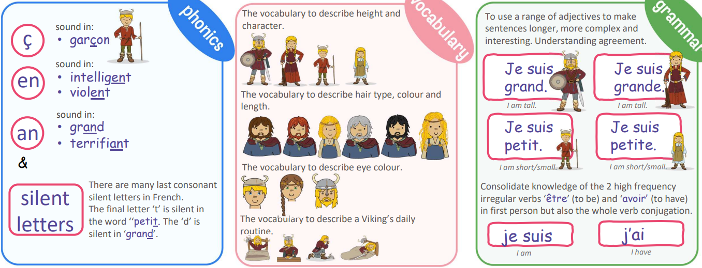  Disciplinary knowledge  I will learn how to decode unfamiliar and more complex language using my knowledge of cognates and history.  I will learn how to describe myself and others physically in terms of height using the verb ‘être’ (to be).  I will learn how to describe myself and others physically in terms of hair colour and type using the verb ‘avoir’ (to have).  I will learn how to describe myself by eye colour using the verb ‘avoir’ (to have).  I will learn how to describe a Viking’s typical daily routine using time phrases

 | CYCLE 2 (B and D)
 | Adaptations: retrieval practice, explicit teaching of new vocab, key vocab mat, drawing, modelling, dual coding, mindmap.
 | Year 3/4 | Year 5/6
Autumn 1 | Instruments (E)  Key learning for week:  - Recognise, recall and spell up to 10 instruments in French with the correct definite article/determiner.  - Understand articles/determiners better and that the definite article/determiner ‘the’ has a plural form in French.  - Learn to say and write ‘I play an instrument’ in French using the highfrequency 1st person regular verb ‘je joue’ (I play) with up to 10 different instruments.  Substantive knowledge  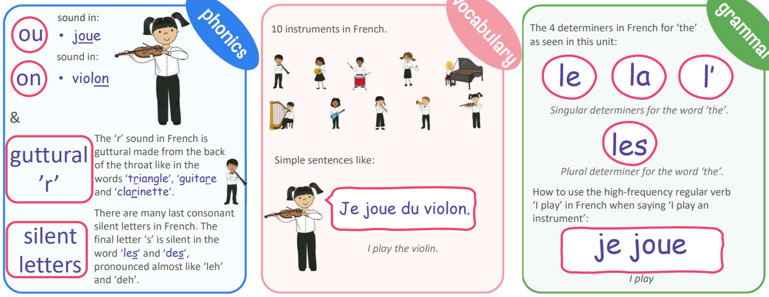  Disciplinary knowledge  I will learn 5 instruments in French with their correct determiner.  I will learn 5 more instrument nouns in French with their correct determiner.  I will revise all 10 instrument nouns with their determiners in French and start to attempt the spellings.  I will explore and understand better the role of the definite article/determiner for ‘the’ in French.  I will learn how to use the first person conjugated verb ‘je joue’ (I play) in French | The date (I)  Key learning for week:  - Repeat and recognise the months of the year in French.  - Ask when somebody has a birthday and say when they have their birthday.  - Say the date in French.  - Create a French calendar.  - Recognise key dates in the French calendar.  Substantive knowledge  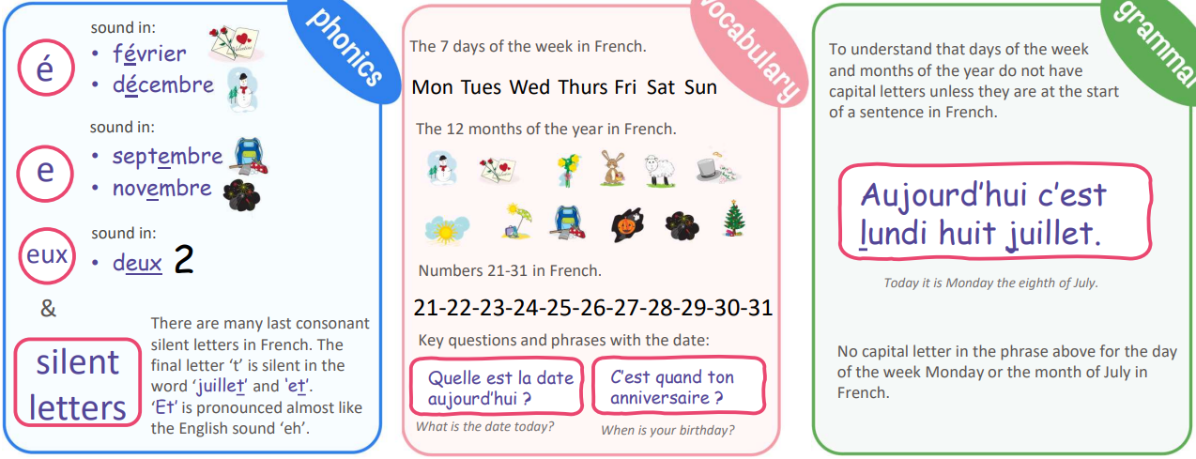  Disciplinary knowledge  I will learn the 7 days of the week in French.  I will learn the 12 months of the year in French.  To learn/revise/consolidate numbers 1-31 in French.  I will learn to ask and answer the question ‘Quelle est la date aujourd’hui ?’ (What is the date today?)  I will learn to ask and answer the question ‘C’est quand ton anniversaire ?’ (When is your birthday?)
Autumn 2 | Seasons (E)  Key learning for week:  - Recognise, recall and remember the 4 seasons in French.  - Recognise, recall and remember a short phrase for each season in French.  - Say which season is their favourite in French and attempt to say why using the conjunctions ‘et’ and ‘car’.  Substantive knowledge  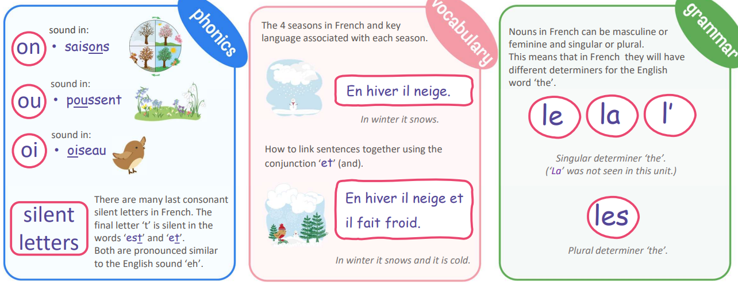  Disciplinary knowledge  I will learn the 4 seasons in French with their determiners.  I will learn a short phrase about winter in French.  I will learn a short phrase about spring in French.  I will learn a short phrase about summer in French.  I will learn a short phrase about autumn in French | Do you have a pet?  Key learning for week:  - Repeat, recognise and attempt to spell the eight nouns (including the correct article for each) for pets in French.  - Tell somebody in French if they have or do not have a pet.  - Ask somebody else in French if they have a pet.  - Tell somebody in French the name of their pet.  - Attempt to create a longer phrase using the conjunctions et (“and”) or mais (“but”).  Substantive knowledge  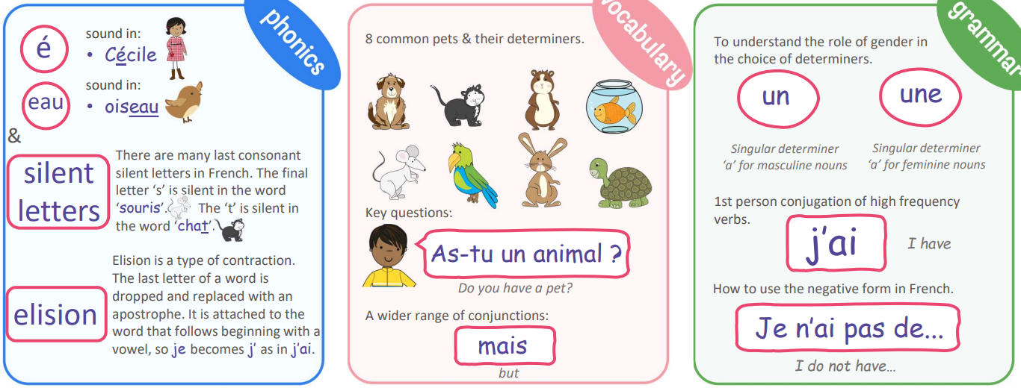  Disciplinary knowledge  I will revise 8 common pet nouns in French with their determiners.  I will learn how to say I have a pet in French.  I will also learn how to say what my pet is called in French.  I will learn how to say what pet I do not have in French.  I will learn how to integrate the conjunction ‘et’ (and) and ‘mais’ (but) accurately into my work
Spring 1 | Vegetables (E)  Key learning for week:  - Name and recognise up to 10 vegetables in French.  - Attempt to spell some of these nouns (including the correct determiner/article)  - Learn simple vocabulary to facilitate a role play about buying vegetables from a market stall.  - Say if they would like one kilo or a half kilo of a particular vegetable or selection of vegetables  Substantive knowledge  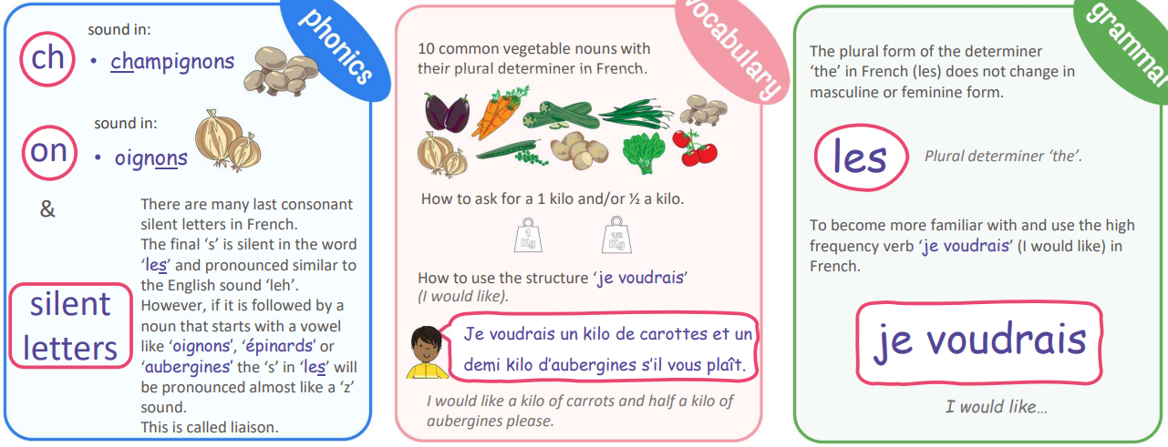  Disciplinary knowledge  I will learn and become familiar with 5 vegetable nouns and their plural determiner in French.  I will learn and become familiar with 5 more vegetable nouns and their plural determiner in French.  I will learn how to ask for a kilo or half a kilo of a vegetable in French.  I will learn how to use the structure ’je voudrais’ (I would like) when buying vegetables.  I will learn how to use the conjunction ‘et’ (and) when buying more than one vegetable option | My home (I)  Key learning for week:  - Say whether they live in a house or an apartment and say where it is.  - Repeat, recognise and attempt to spell up to ten nouns (including the correct article for each) for the rooms of the house in French.  - Tell somebody in French what rooms they have or do not have in their home.  - Ask somebody else in French what rooms they have in their home.  - Attempt to create a longer spoken or written passage in French recycling previously learnt language.  Substantive knowledge  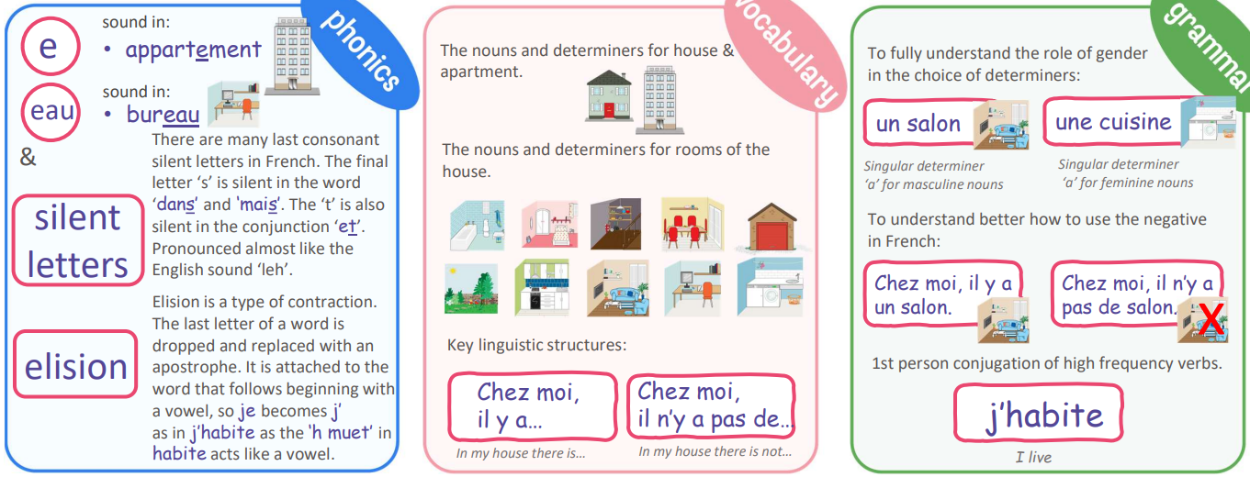  Disciplinary knowledge  I will learn how to say where I live using the first person high frequency verb ‘j’habite’ (I live)  I will learn 5 nouns and their determiners for rooms of the house.  I will learn 5 more nouns and their determiners for rooms of the house.  I will learn how to say I do not have a particular room in the house using a key negative structure.  I will use all my new knowledge in French to describe where I live
Spring 2 | Ice-creams (E)  Key learning for week:  - Name and recognise up to 10 different flavours for ice creams.  - Ask for an ice-cream in French using ‘je voudrais’.  - Say what flavour they would like.  - Say whether they would like a cone or a small pot/tub of ice-cream.  Substantive knowledge  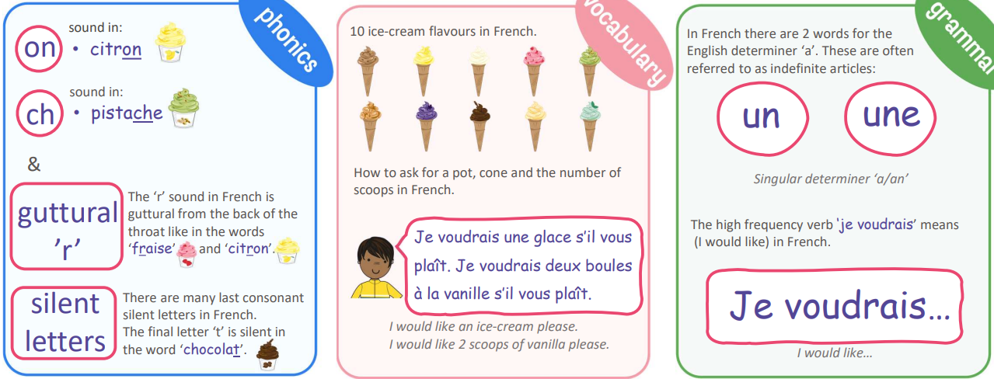  Disciplinary knowledge  I will learn and become more familiar with 5 ice-cream flavours in French.  I will learn and become more familiar with 5 more ice-cream flavours in French.  I will learn how to use the first person high frequency verb ‘je voudrais’ (I would like) in French.  I will learn how to ask for a cone or a pot of ice-cream and say the number of scoops I would like.  I will learn how to use all my new knowledge to perform a short role-play to order an ice-cream. | What is the weather? (I)  Key learning for week:  - Repeat and recognise the vocabulary for weather in French.  - Ask and say what the weather is like today.  - Create a French weather map.  - Describe the weather in different regions of France using a weather map with symbols.  Substantive knowledge  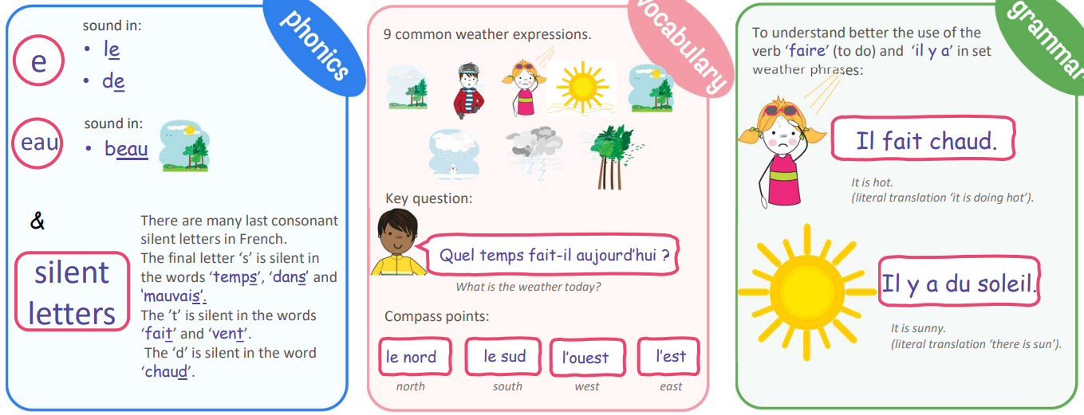  Disciplinary knowledge  I will be introduced to the new vocabulary for describing the weather in French.  I will start to learn how to recall, say and write the weather expressions from memory.  I will learn to improve my listening decoding skills.  I will learn how to read a weather map in French and describe weather in different parts of the country.  I will use all my new knowledge to present a weather forecast in French.
Summer 1 | My family (I)  Key learning for week:  - Tell somebody the members, names and various ages of either their own or a fictional family in French.  - Continue to count in French, with the option of reaching 100, enabling students to say the age of various family members.  - Understand the concept of the possessive adjectives ‘mon’, ‘ma’ and ‘mes’ in French.  - Move from 1st person singular to 3rd person singular of the two high frequency verbs used in this unit: s’appeler (to be called) and avoir (to have).  Substantive knowledge  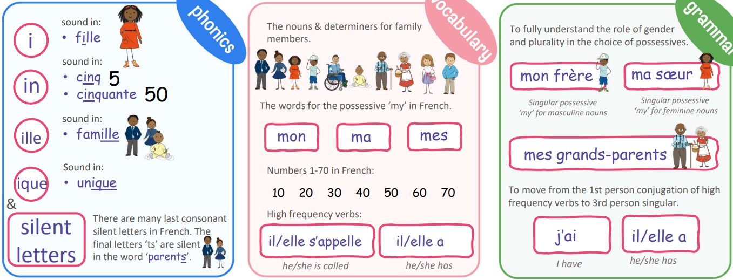  Disciplinary knowledge  I will learn how to move from using the determiner ‘a’ with a family member noun to using a possessive adjective ‘my’ in French.  I will learn to answer the question ‘As–tu des frères et sæurs ?’ (Do you have any brothers or sisters?)  I will learn how to introduce family members, learning to use ‘il/elle s’appelle’ (he/she is called).  I will use my knowledge of larger numbers to be able to describe the age of family members | At school (P)  Key learning for week:  - Repeat and recognise the vocabulary for school subjects.  - Say what subjects they like and dislike at school.  - Say why they like/ dislike certain school subjects.  - Tell the time (on the hour) in French.  - Say what time they study certain subjects at school.  Substantive knowledge  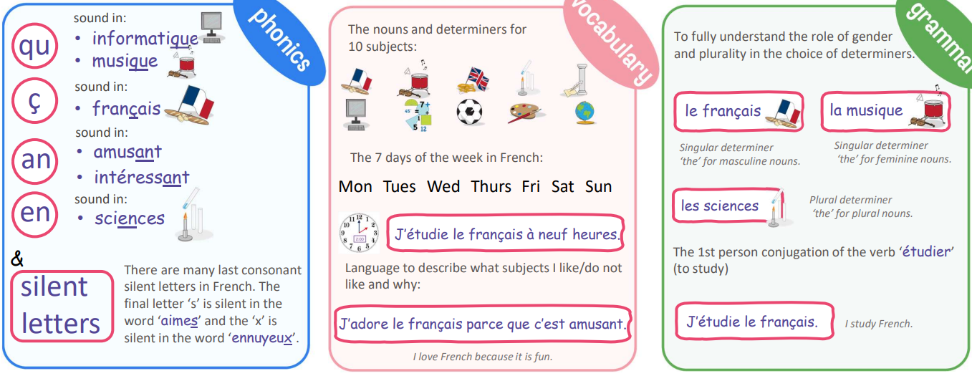  Disciplinary knowledge  I will learn the nouns and determiners for 10 classroom objects in French.  I will learn how to create a short phrase in French in a subject using I like and I do not like.  I will learn how to answer the question ‘Quelle heure est-il ?’ (What time is it?) on the hour in French.  I will learn how to say at what time I study a particular subject in French.  I will use all my new knowledge from the unit to present my school preferences to the class in spoken and/or written form
Summer 2 | In the classroom (I)  Key learning for week:  - Remember and recall 12 classroom objects with their indefinite article/determiner.  - Replace an indefinite article/determiner with a possessive adjective.  - Say and write what they have and do not have in their pencil case.  Substantive knowledge  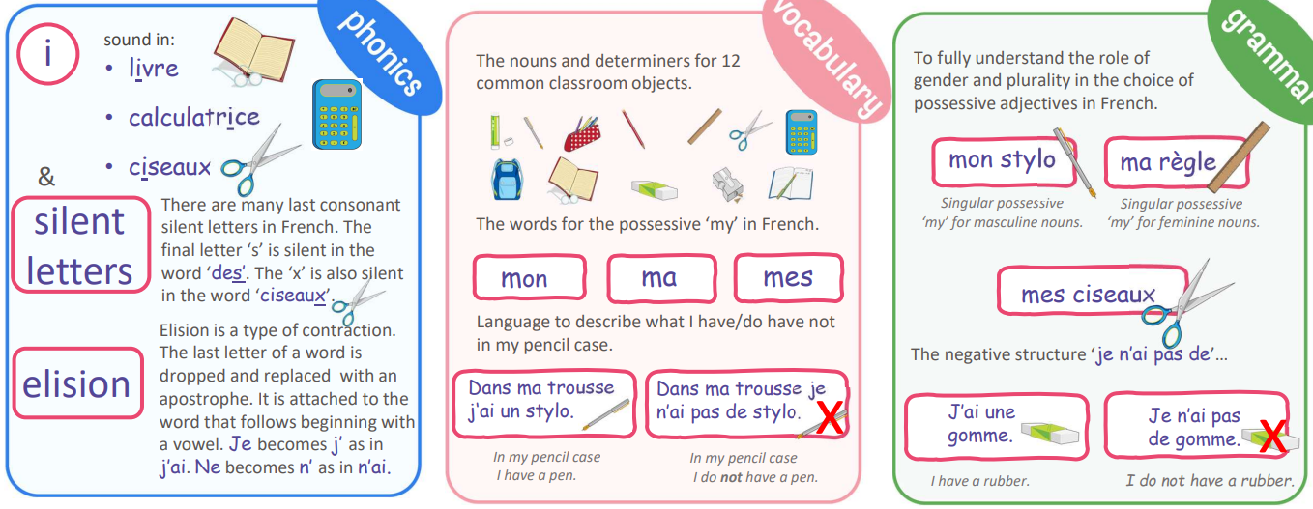  Disciplinary knowledge  I will learn the nouns and determiners for 6 classroom objects in French.  I will learn 6 more nouns and their determiners for classroom objects in French.  I will learn how to answer the question ‘Qu’est-ce qu’il y a dans ta trousse ?’ (What do have in your pencil case?)  I will learn how to move from an indefinite determiner (a) to a possessive adjective (my) in French.  I will learn the negative response and use all my new knowledge to say what I have/do not have in my pencil case | Me in the world (P)  Key learning for week:  - About the many countries in the Francophone world.  - About different festivals (religious and non-religious) around the world.  - That we are different and yet all the same.  - That we can all help to protect our planet.  - How to use “à” (when talking about living in a city) and “en/au/aux” (when talking about living in a country).  Substantive knowledge  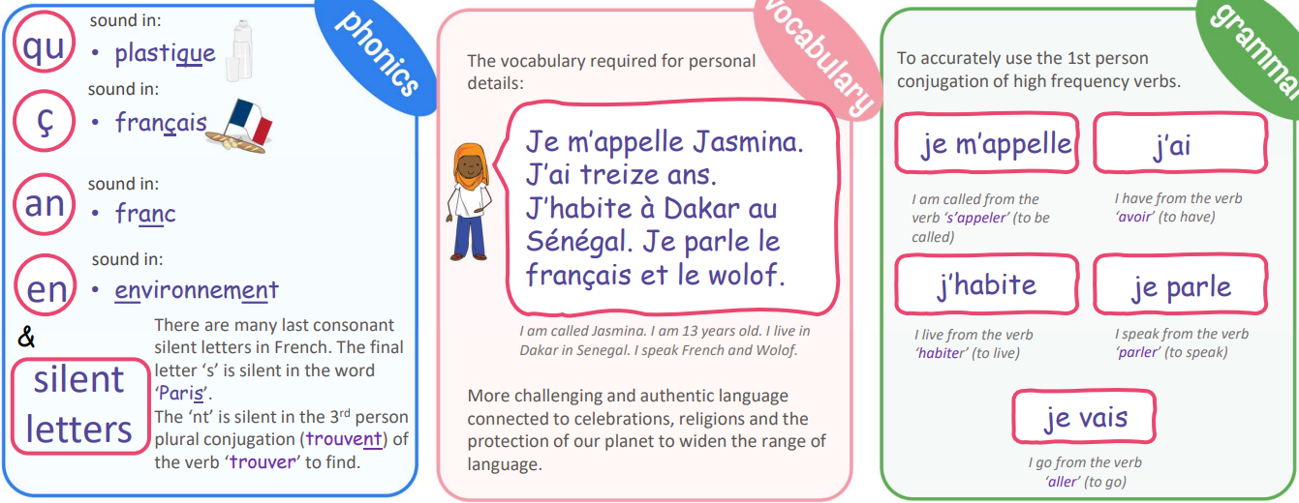  Disciplinary knowledge  I will learn more about the 4 characters in the unit and the Francophone world.  I will learn more about the different celebrations celebrated in the Francophone world.  I will learn more about 2 different religious celebrations celebrated in the Francophone world.  I will improve my cultural awareness of Paris in France and Port-au-Prince in Haiti.  I will learn how the 4 characters are more responsible global citizens by doing more to protect the planet.
National Curriculum Programmes of Study
Pupils should be taught to:
- listen attentively to spoken language and show understanding by joining in and responding
- explore the patterns and sounds of language through songs and rhymes and link the spelling, sound and meaning of words
- engage in conversations; ask and answer questions; express opinions and respond to those of others; seek clarification and help*
- speak in sentences, using familiar vocabulary, phrases and basic language structures
- develop accurate pronunciation and intonation so that others understand when they are reading aloud or using familiar words and phrases*
- present ideas and information orally to a range of audiences*
- read carefully and show understanding of words, phrases and simple writing
- appreciate stories, songs, poems and rhymes in the language
- broaden their vocabulary and develop their ability to understand new words that are introduced into familiar written material, including through using a dictionary
- write phrases from memory, and adapt these to create new sentences, to express ideas clearly
- describe people, places, things and actions orally* and in writing Languages – key stage 2 3
- understand basic grammar appropriate to the language being studied, including (where relevant): feminine, masculine and neuter forms and the conjugation of high-frequency verbs; key features and patterns of the language; how to apply these, for instance, to build sentences; and how these differ from or are similar to English.

