Spires Federation


Hoglets Admissions Policy

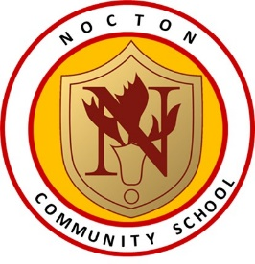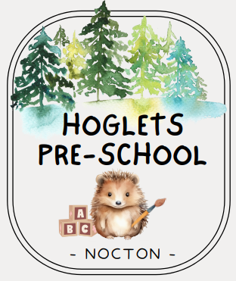

Date : September 2025
Review Date: September 2026

Nocton Community Primary acts as the administration for Hoglets Pre-School and will allocate places for term time sessions. Hoglets Pre-school accepts children from the age of 3 years up to school age.

Funding:

Funded places are available for 3-year-olds meeting specific criteria found at www.childcarechoices.gov.uk

Eligibility

This is a total of 30 hours of free childcare per week, over 38 weeks or the equivalent number of
hours across more weeks per year. Most working parents are eligible for 30 hours of free childcare each week. If you (and your partner, if you have one) work then you will be entitled to 30 hours of free childcare if you (and your partner) earn the equivalent of 16 hours per week at national living wage or earn less than £100,000 per year.

The 30 hours free childcare entitlement can be used with any approved childcare provider (i.e. nursery or childminder) and can be split across more than one provider. For example, your child could attend a nursery setting for 15 hours and the remaining 15 hours could be used with a childminder. You can use the Government website https://www.childcarechoices.gov.uk to check what you are eligible for given your own personal circumstances.

Families’ eligibility for 30 hours must be reviewed every three months.

Government reminder notices will be sent to the 30-hour place families to remind them near the time that they need to re-visit the Government website Sign in to your childcare account - GOV.UK to update their current personal circumstances and then pass their new reference number to the school office in order to keep their 30-hour place for the following term.

Attendance at Hoglets does not guarantee admission to our reception class nor give advantage to a child’s application to our reception class. Parents must make a separate application for the transfer from a nursery to a primary or infant school to the Local Authority.

Places:
We have a maximum number of 8 Hoglets spaces per session. Places are determined by the number of Primary Age children on the school role. These pupils take priority and this may mean that we have to reduce the number of pre-school places if our Primary school role increases.
Those places will be allocated for those children who are eligible which are allocated on a first come first served basis. Admission into Pre-School is governed by the school and not the Local Authority.
We accept 15 hour and 30 hour funded places. The fees above are for any hours outside of these 15/30 funded hours (morning/afternoon sessions). Additional fees are invoiced at the end of each calendar month via Arbor Parent Portal.
Item | Description | Cost
Breakfast Club WAC | Wrap Around Care from 8am to 8:50am (includes breakfast) | £5.00
Early Drop Off WAC | Wrap Around Care from 8:30am – 8:50am (does not include breakfast) | £2.50
Morning Session | 8:50am – 11:50am (3 hours) | £15.30
Afternoon Session | 11:50am – 2:50pm (3 hours) | £15.30
Additional Session for full afternoon | 2:50pm – 3:20pm (30 minutes) | £2.55
Early Afternoon WAC | Wrap Around Care from 3:20pm to 4:00pm | £4.50
Late Afternoon WAC | Wrap Around Care from 3:20pm to 5:00pm (includes a snack) | £9

Procedures for Admission
We will allocate all places based on the soonest start date and on a first come, first served basis. It is therefore very important that your details on the Expression of Interest/Booking Form highlight your requirements and if applicable, flexibility.
There will be no other criteria applied other than the dates that are submitted on the Expressions of Interest form.

The school will only allocate nursery sessions once it has determined that a place can be offered in accordance with the admission criteria. If an applicant is offered a place they must confirm acceptance directly with the school by the date on in their offer letter. Where the nursery is oversubscribed, it will maintain a waiting list in criteria order.

If you would like to request a place in Hoglets for your child please complete and return this form to Nocton Community Primary School. Once your application is received it will remain on file until places are allocated as per the admissions policy. We will confirm that we are able to offer a place for your child four weeks before the preferred start date, arrange their admission and confirm the sessions.

Pre-school children will have their provision in the same classroom as our existing Reception children and may at times work with them.

Expression of Interest/Booking Form
Hoglets Pre School Booking form
Full name of Child: | DOB:
Name of parent/carer: | Telephone Number:
Address: | Postcode:

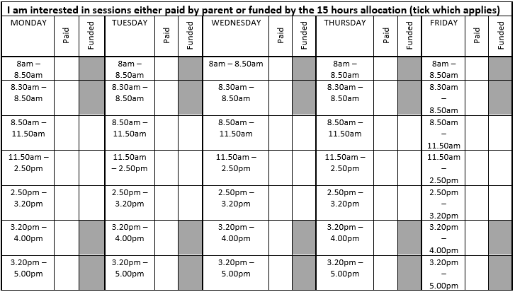

Is this child ‘Looked After’?  Y / N | Does your child have siblings at Nocton Community Primary?  Y / N
Does your child have additional needs?
Y / N
Will Nocton Pre School be the only provider?  Y / N | If no, please state additional provider:
Any other information:
Signed (Parent/carer):
Date:

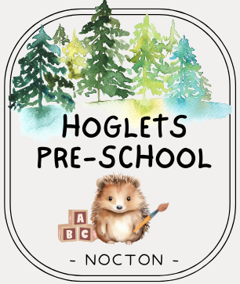  Fees Breakdown |  | Hoglets Pre-School  Nocton Community Primary School  The Green  Nocton  LN4 2BJ  01526 320234  admin@spiresfederation.co.uk

Item | Description | Cost
Breakfast Club WAC | Wrap Around Care from 8am to 8:50am (includes breakfast) | £5.00
Early Drop Off WAC | Wrap Around Care from 8:30am – 8:50am (does not include breakfast) | £2.50
Morning Session | 8:50am – 11:50am (3 hours) | £15.30
Afternoon Session | 11:50am – 2:50pm (3 hours) | £15.30
Additional Session for full afternoon | 2:50pm – 3:20pm (30 minutes) | £2.55
Early Afternoon WAC | Wrap Around Care from 3:20pm to 4:00pm | £4.50
Late Afternoon WAC | Wrap Around Care from 3:20pm to 5:00pm (includes a snack) | £9
We accept 15 hour and 30 hour funded places. The fees above are for any hours outside of these 15/30 funded hours. Additional fees are invoiced at the end of each calendar month via Arbor Parent Portal.

