Spires Federation
Policy



SEND Policy

Date : September 2025
Review Date: September 2026

Introduction
At Nocton Community Primary School, we are committed to offering an inclusive curriculum to ensure the best possible progress for all our pupils whatever their needs or disabilities. This policy should be read in conjunction with the SEND Code of Practice (2014) and other relevant school policies.

Definition of Special Educational Needs (SEN)
"A child or young person has SEND if they have a learning difficulty or disability which calls for special educational provision to be made for them. A child of compulsory school age or a young person has a learning difficulty or disability if they:
a) have a significantly greater difficulty in learning than the majority of others of the same age; or
b) have a disability which prevents or hinders them from making use of educational facilities of a kind generally provided for others of the same age in mainstream schools or mainstream post-16 institutions." (SEND code of Practice 2014)

Definition of Disability
'A physical or mental impairment which has a substantial and long-term effect on the ability to carry out normal day-to-day activities' (Equality Act of 2010)
The purpose of this document is to ensure that all stakeholders, including parents, teaching staff and governors understand and use a consistent approach in implementing support for young people with special educational needs.
- Aims and Objectives
  - To identify every child with special educational needs and disabilities and ensure that their needs are met.
  - To ensure that children with educational needs and disabilities join in with all the activities of the school.
  - To ensure that all children with special educational needs make good progress.
  - To ensure that there is effective communication with parents and that they are kept informed of their child's special needs and the provision they receive.
  - To ensure that every child with a special educational need can express their views and wishes and are fully involved in decisions which affect their education.
  - To promote effective partnerships and involve outside agencies when appropriate.

- Roles and Responsibilities
  - The Governing Body has a statutory duty towards the pupils with special educational needs. In partnership with the Head teacher, they decide the school's general policy and approach to meeting provision for those children with special educational needs. They set up appropriate staffing and funding and report to parents annually on the school's policy on special educational needs.
  - The Headteacher is responsible for the daily provision of children with SEN. The Headteacher also has a duty to keep the Governing Body regularly informed regarding issues and progress relating to pupils with SEND and works closely with the SENDCo to co-ordinate provision.
  - All staff are responsible for being aware of the procedures for identifying, assessing and providing provision for children with SEND.

Teachers:
By making themselves aware of this policy and procedures for identiﬁcation, monitoring and supporting pupils with SEND; seeking advice from the SENCO on assessment and strategies to support inclusion as necessary; providing for pupils with SEND in their class, and to be aware that these needs may be present in diﬀerent learning situations; including pupils with SEND in the classroom, and for providing an appropriately diﬀerentiated curriculum; giving feedback to parents/carers of pupils with SEND.

Support staff:
To be fully aware of this policy and the procedures for identifying, assessing and making provision for pupils with SEND; use the school’s procedures for giving feedback to teachers about pupils’ responses to tasks and strategies.

  - The SENDCo works closely with the staff and is involved in the development of the SEND policy and provision. The SENDCo has the responsibility:
- For co-ordinating provision for children with SEND
- Ensuring the day to day implementation of the policy
- The day-to-day operation of the school’s SEND policy;
- Liaising with and advising school staff giving clear guidelines for procedure when needs are identified;
- Maintaining the school’s SEND register, which is updated each term, and overseeing records of pupils with SEND;
- Monitoring the completion of class Provision Maps to record intervention for all children who need any additional support.
- Liaising with parents of pupils with SEND;
- Contributing to in-service training of staff, which may be built into the SDP;
- Liaising with external agencies including the Specialist Teaching Team, Working Together Team and other SEN support services, medical, social services and voluntary bodies;
- Consulting with SENDCos from other schools to ensure effective use of resources and the dissemination of good practice;
- Managing a range of resources, human and material, linked to children with SEND;
- Supporting and advising colleagues;
- Monitoring and evaluating the special needs provision and reporting to the Governing Body.

For the academic year 2025-2026, the SENDCo is Miss Natalie Vaughan.

  - Parents play an essential role in contributing to the identification of a child’s special need. There is close liaison with parents to ensure their child’s needs are being met and parents are invited to termly reviews of their child’s progress.
  - The school has positive attitudes to parents/carers, provides user friendly information and strives to ensure that they understand the procedures and are aware of how to access advice and support. Parents/carers will be supported and enabled to: Recognise and fulﬁl their responsibilities as parents/carers and play an active and valued role in their child’s education; Have knowledge of their child’s entitlement within the SEND framework; Make their views known about how their child is educated; Have access to information, advice and support during assessment and any related decision making processes about Special Educational provision. In accordance with the school’s ‘Open Door’ policy, parents/carers are encouraged to contact the school office to arrange a meeting with the SENDCo as needed either by telephone or appointment.. Parents/Carers are involved in supporting the target setting process for Pupil proﬁles and their views are sought for reviews. We encourage active participation of parents/carers by providing guidance on how they can support their child’s learning at home. We value the contribution that parents/carers make and the critical role they play in their child’s education. All parents/carers of children with SEND will have access to the school’s information about Special Educational Needs on the website and this information can also be made available in hard copy on request. Parents/carers will be signposted to the Local Authority Local oﬀer for further information.
  - Pupils with SEND often have a unique knowledge of their own needs and circumstances, and their own views about what sort of support they would like to help them make the most of their education. They will be encouraged to participate in the decision-making processes including the setting of learning targets and contributing to Pupil proﬁles. This will be achieved through a variety of diﬀerent approaches as appropriate to the age of the child. These include:
- Pupil interviews
- Questionnaires
- Self-evaluation (pictures, written answers)
- Pupil set targets

Admission Arrangements
Nocton Community Primary School is an inclusive school. We admit children with already identified special educational needs as well as identifying and providing for pupils not previously recognised as having SEND.

Provision
At Nocton Community Primary School pupils are provided with high quality support from a range of sources:

In School support

All staff have regular support relating to SEND. The SENDCo updates staff at staff meetings and will arrange any additional training that is required when staff request this. The SEND action plan includes on-going training to meet the needs of pupils with a range of difficulties. Some teaching assistants have been employed to specifically work with pupils who have difficulties with special needs.

External support

- The speech and language service may attend school to assess and support children with speech and language difficulties. Before a referral can be made, the school must carry out a ‘Speech Sounds Assessment’ to determine whether the child meets the criteria for referral.
- The Working Together Team (Social Communication Outreach Service) provides support and advice for children with additional needs including Autism and ADHD.
- Close relationships with Social Care, Health partners and voluntary organisations are also maintained.
- The Specialist Teaching Team supports the SENDCo and the teaching staff by carrying out assessments in order to provide targets for intervention and support for further learning. They also provide training for teaching and support staff; parental support and developing parents’ understanding of literacy difficulties.

5. Facilities and Equipment
  - Our school site is accessible by road and has parking spaces close to the gate, if needed. The school is on two floors, however all classrooms are on the ground floor, with only staff using the second floor. There is ramp access outside. There is also a large disabled toilet within the main building. The school undertakes an annual accessibility audit and has an action plan. Some targets are short term, some are medium term, but others are longer term and require help and funding from the LEA. Where needed, we would seek advice from occupational therapy for support.

  - Children's needs are met wherever possible within their classrooms. In addition, other rooms are available for children to use. The library is used for teaching children on a one-to-one basis or for small group work. It is also available for children who need to be withdrawn to a quiet and calm environment. CASY counselling sessions are also ran from in here. Each classroom contains a well-being display, check in/emotions area and a comfy reading/well-being area. The school aims to keep children identified as having SEND in their own classroom following the curriculum wherever possible through the use of our Curriculum Adaptation Map document.

6. Allocation of resources
  - The SEND budget is allocated to the school annually, and is linked to the number of children on the SEND register. The majority of the budget is used to fund Teaching Assistants who are then often used to provide support to children with difficulties. In addition, children with Educational Health Care Plans (EHCP) receive individual allocations of funding (Top up funding) which are allocated to meet the specific needs identified on the annual review statement.
  - Every attempt is made to ensure that all pupils with SEN have access to any resources that will assist their development. Support reading schemes are available in school as and when necessary. Curriculum leaders are responsible for resources for their own area and will have regard for any specialist equipment if thought to be necessary and the budget restraint allows.

7. Access to the curriculum
All children with special educational needs have the right to access the full curriculum. The class teacher is responsible for correctly pitching activities to maximise a child's access to the curriculum. The school has a Curriculum adaptation map and provision map which outlines the support given to our pupils.

8. Identification and Assessment
8.1 The school is committed to the early identification, assessment and provision for a child with special educational needs. A range of evidence is collected through a variety of assessments and monitoring arrangements, including:
- Their performance monitored by the teacher as part of their on-going observations and assessment.
- The outcomes from baseline assessment results.
- Their progress against age-related expectations specified in the National Curriculum.
- Standardised screening or assessment tools.
- Their performance against National Curriculum levels at the end of a Key Stage.
- Specialist Teaching Team Assessment
- Working Together Team observation and assessment

8.2 If a child is considered not to be making the expected progress, the class teacher will consult with the SENDCo in order to decide whether additional and or different provision is necessary. The school has a graduated approach to intervention and provision, which was recommended in the SEN Code of Practice (2014).
The support provided consists of a four-part process:
- Assess
- Plan
- Do
- Review
This is an on-going cycle to enable the provision to be refined and revised as the understanding of the needs of the pupil grows. This cycle enables the identification of those interventions which are the most effective in supporting the pupil to achieve good progress and outcomes.

9. Expression of concern
  - If a child's progress causes some concern for the class teacher, member of staff or parent, a discussion with the relevant members of staff and parents will take place. The child will be monitored by the class teacher through the class provision map which will identify the child’s specific difficulties, strategies to help overcome these difficulties and a time schedule for the intervention. Exit criteria will be set and a date for review will be made. Support for the child will be provided by the class teacher and teaching assistant through quality first teaching and appropriate differentiation.
  - If a child presents social, emotional or behavioural concerns to the class teacher, member of staff or parent, a discussion with the relevant members of staff and parents will take place. The child will be monitored by the class teacher who will identify the child’s specific needs and the strategies that will help to overcome these difficulties. A Pastoral Support Plan may be written and a time schedule for the intervention will be made. Support for the child will be provided by the class teacher, teaching assistant and the SENCo. A date for review of the child’s needs will be made and advice from appropriate support agencies will be sought. In addition to this, advice and support from outside agencies such as CASY and internal staff, such as a trained Emotional Literacy Support Assistant can work with individuals.
  - After the review of the child’s progress, a decision will be made in order to decide whether the problem is resolved or if the child continues to need appropriate intervention in order to meet their needs. A child who continues to make less than expected progress given their age and individual circumstances may:
- Make progress that is significantly slower than that of their peers starting from the same baseline
- Fail to match or better his / her previous rate of progress
- Fail to close the attainment gap between themselves and their peers
  - Where progress continues to be less than expected the class teacher, working with the SENDCo, should assess whether the child has SEND, as slow progress and low attainment do not necessarily mean that a child has SEND and should not automatically lead to a pupil being recorded as having SEND.
  - Appendix 1 illustrates this journey in a flow diagram.

10. Placing children on the SEN register
10.1 Children who are deemed to have SEND will be placed on the school's SEND register. They will receive intervention determined by the nature of their specific needs. This will be recorded on the Class Provision Map which will seek to ensure that the child’s individual needs are met and that they make good progress. A Support Plan will be set up by the SENDCo and class teacher together with the child, which records the child’s strengths, what they enjoy, what supports them and which areas they want to work on. Targets will be set, which may outline a more structured programme to meet a specific need or may be an intensive focused intervention to secure a skill that is preventing the child from making progress.
10.2 When targets are written this will be with the class teacher, support staff, parent and the child when the following will be discussed:
- The short term targets set for the child
- The teaching strategies to be used
- The provision to be put in place
- When the plan is to be reviewed
- How success will be celebrated
The Support Plan targets should only record that which is additional or different from the normal differentiated curriculum. It should contain 3 or 4 targets relating to the key areas of communication, English, mathematics and behaviour and social skills. The class teacher will be responsible for ensuring an adult works with the child on a regular basis and planning and delivering a differentiated curriculum to address the difficulties identified in the Plan.
Some pupils may receive additional support outside of the classroom. This will be determined by the individual pupil's needs. Targets will be reviewed on a termly basis and the outcomes will be recorded. Pupils and parents will be involved fully in the review process. (See Appendix 2)
10.3 At the review it will be decided whether a child will either:
- Be removed from SEND register because significant progress has been made and the child's needs can now be addressed through a normal differentiated curriculum.
- Remain on the SEND register as further focused intervention will address ongoing additional needs. Sometimes external agencies may be contacted at this point (with parental permission) for further advice and support. These professionals will contribute to monitoring and reviewing progress and any further assessments that may be planned to identify a child's specific needs.
The SENDCo will arrange a mutually convenient time to meet with parents to review progress and discuss new targets on a termly basis. During this meeting parents will be provided with the opportunity to contribute to the targets. Parents are also encouraged to discuss any other concerns and the SENDCo will keep parents informed of the involvement of outside agencies and proposed interventions.

11. Educational Health Care Plans

  - Where a child has demonstrated significant cause for concern, and all other intervention stages have had insufficient success in meeting a child's needs, the school may request statutory assessment. If the child meets the needs of the criteria outlined by the LA, the child may receive an Education Health Care Plan (EHCP). This will outline the targeted outcomes that will enable the child to progress, identify resources and allocate funding to meet the child's needs. The EHCP will be reviewed annually with involvement of the parents, pupils and the appropriate outside agencies. A report will then be written for the Local Authority. (See Appendix 3)
  - When pupils are due to transfer to another school, planning for this will be started in the year prior to transfer. Advanced planning for children in Year 5 will allow appropriate options to be considered. It is the responsibility of the SENDCo to liaise with the SENDCo of the local secondary schools to ensure that effective arrangements are in place to support pupils when they transfer.

12. Record keeping
The SENDCo is responsible for keeping detailed records on all pupils on the SEND register. Each child on the register has a tab on Arbor which contains: support plans, advice from outside agencies, meeting notes and medical advice.

13. Training
Staff are kept up to date with relevant training. Training needs are constantly under review and staff will receive training as necessary.

14. Bullying
Nocton Community Primary School takes all necessary steps to ensure and mitigate the risk of bullying of vulnerable learners (see School’s Anti-bullying Policy). We always aim to safeguard the needs of pupils with SEND, promote independence and build resilience in their learning by educating the whole school community about respecting individuality and diversity

15. Dealing with complaints
Close liaison with parents at all stages of the special needs process should minimise disputes. However, any complaints will initially be dealt with by the class teacher, then the SENDCo/Head teacher. If this is unsuccessful the complaint will be referred to the Governing Body and ultimately the LA.

16. Evaluation
This school policy has been agreed by the Headteacher, teaching staff and support staff.
The policy was presented and approved at the full Governing Body.

Signed:
Chair of Governors: ……………………………… Mr A Hancy

Headteacher ………………………………………… Miss D Winters

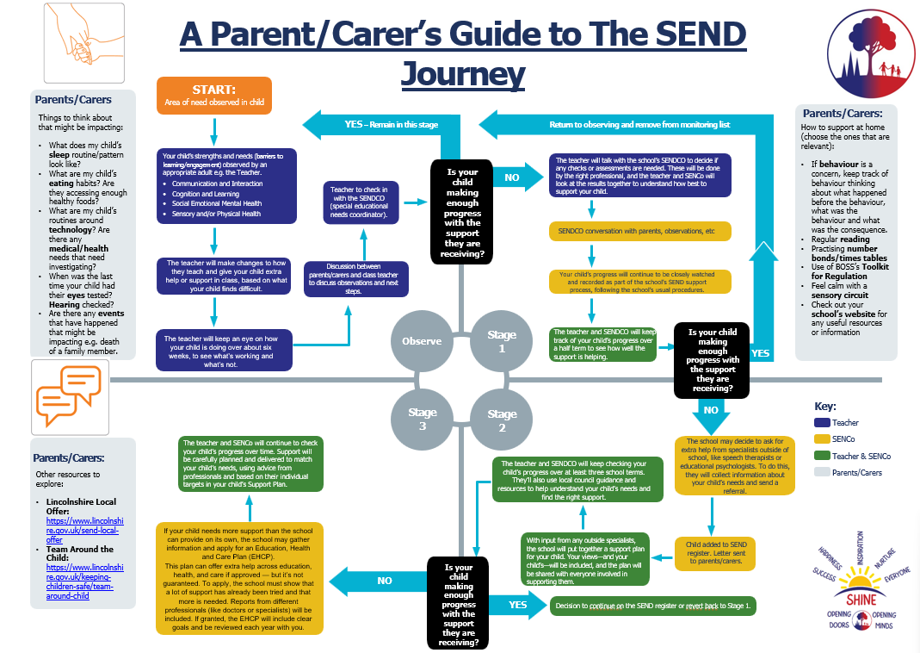
Appendix 1:

Appendix 2:

How to prepare for an SEND review:
Check the child’s progress against the last targets and make notes to take to the review meeting. This may also include ideas for the child’s next steps. The SENDCo will coordinate the review meetings across school. When meeting with parents/carers you must remember to sign the ‘gold’ form and ask parents/carers to sign as a record of meetings that have taken place. The review will usually be led by the SENDCo, however the class teacher must come prepared to talk about the child, current provision and progress against their last targets. Occasionally, the class teacher will carry out the review meeting and feedback to the SENDCo in order for file records to be updated.

Appendix 3:
How to prepare for an annual review:
The SENDCo or a key person will coordinate and chair the meeting. About 4-6 weeks prior to the review the SENDCo will send a letter of invitation and feedback sheets. Class teachers must make sure that they are familiar with the contents of the statement/EHC plan and particularly with the objectives and the provision. Class teachers might like to make notes about progress towards the statement objectives and must be prepared to talk about the provision that is in place. Remember that the provision that is outlined in the EHC plan must be delivered as it is a legal document and you will need to evidence progress towards the objectives. Class teachers will be asked to ensure that the views of the child are collected (the SENDCo will send a sheet to be completed with the child) The SENDCo will ensure that all viewpoints are considered during the review (including any views of the pupil) and all present will be asked to say whether the level of support is still appropriate.

